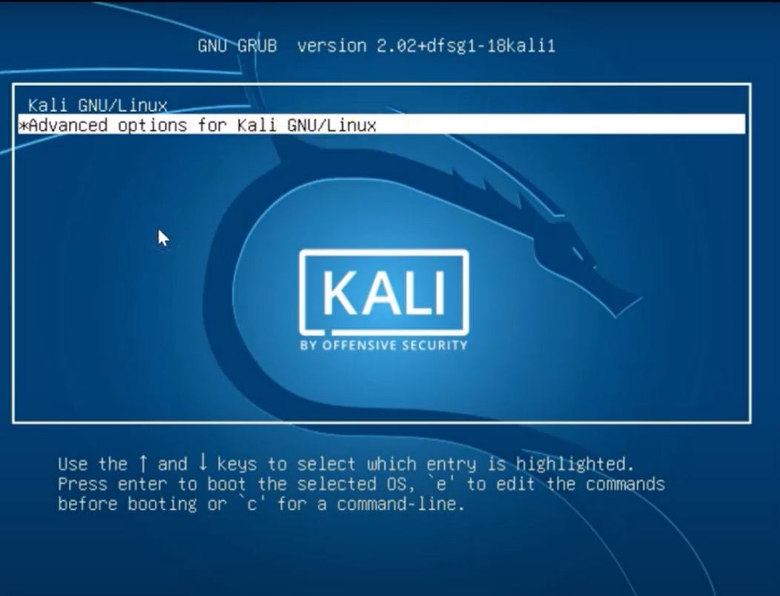

Click Enter after going to option advanced option for kali GNU/Linux

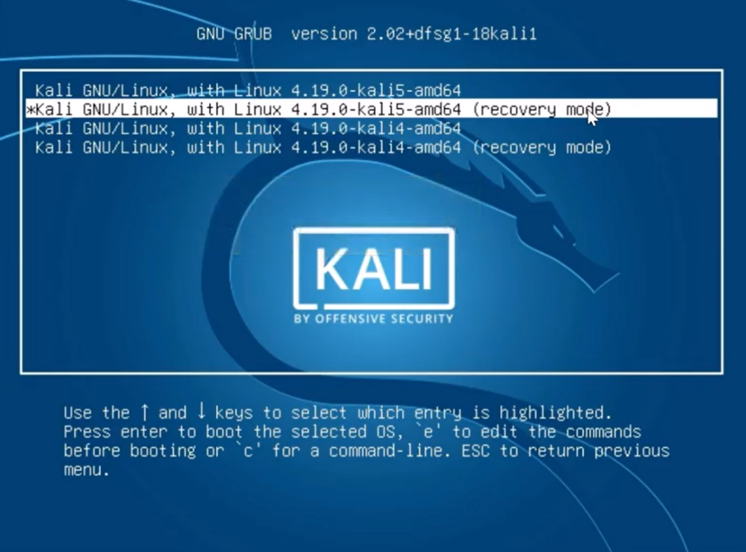

After that go to optiom Kali GNU/Linux, with Linux 4.19.0-kali-amd64(recovery mode) and press e

